Exporting Frequent Contacts From GroupWise
To save your Frequent Contacts from GroupWise, please do the following.

Exporting Frequent Contacts
- Open GroupWise and click the Address Book icon.
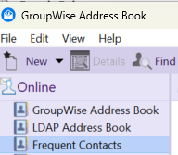
- Select Frequent Contacts in the address book list.
- Next, click File, then click the Export option.
- The Choose Address Book window will appear.
Select Frequent Contacts, then click OK.
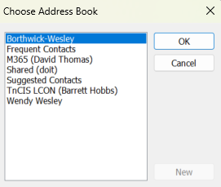
- The Choose Export File will open.
  - Select Desktop as the save location,
  - Type the name Frequent Contacts in the File name field.
  - Select the Comma Separated Value (.csv) file format in the Save as type dropdown.
  - Click Save.
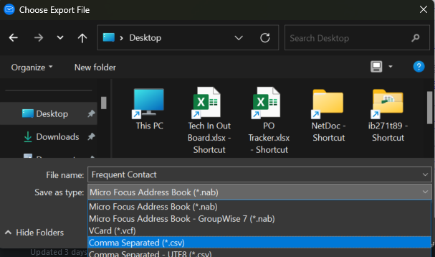

Importing Frequent Contacts to Outlook
To add your saved Frequent Contacts to Outlook, please do the following.

Importing Frequent Contacts
- Open Outlook and click File, then Open & Export.
- 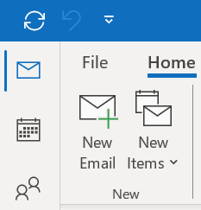
- Select Import/Export.
- 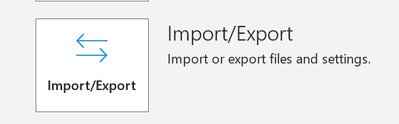
- Select Import from another program or file, then click Next.
- Select Comma Separated Values.
- Browse to the location where you saved your GroupWise contacts .csv.
- Select Do not import duplicate items.
- Select the Address Book you want to import. (should be a .csv format)
- Click Next.
- Click Finish. (Please check your Outlook contacts to confirm contacts are present.)

